Low Level Design (LLD)

# New and Old book Purchase System (Web Application)

Revision Number: 1.0

Last date of revision: 03/01/2024

# Document Version Control

|  |  |  |  |
| --- | --- | --- | --- |
| **Date Issued** | **Version** | **Description** | **Author** |
| 03/01/2024 | 1.0 | Initial LLD – V1.0 | Rahul Suregaonkar |
|  |  |  |  |
|  |  |  |  |
|  |  |  |  |
|  |  |  |  |
|  |  |  |  |
|  |  |  |  |

**Contents**

Document Version Control 2

Abstract 5

1. Introduction 6
   1. Why this Low-Level Design Document? 6
   2. Scope 6
   3. Constraints 7
   4. Risks 8
   5. Out of Scope 8
2. System Architecture 8
   1. System Architecture Workflow 8
   2. Django System Architecture 9
   3. Django ORM Architecture 11
   4. Data Base 13
   5. Web Server 15
   6. Application Server 17
   7. Logging and Monitoring 18
3. Module Wise Details 21
   1. User Registration 22
   2. Book Catalogue and Filtering 24
   3. Comments System 26
   4. Basket or Cart System 28
   5. Add To Wishlist 32
   6. Book Recommendation 33
   7. Adding User Address 34
   8. Book Purchase (Buy) 36
   9. Stripe API Payment 39
   10. Order Tracking System 40
   11. Book Listing (Sell) 45
   12. Blogs 45
4. Technology Stack 47
5. Detailed Database Design 48
6. Code Structure 49
7. Error Handing 50
8. Security Measures 52
9. Performance Optimization 52
10. Test Cases 54
11. Conclusion 55

# Abstract

Embark on a literary journey with our meticulously crafted web application, a synthesis of cutting-edge technology and user-centric design. Leveraging the Django framework, this platform seamlessly integrates a robust eCommerce module and an innovative book exchange marketplace. Users can not only browse, purchase, and discover their next favourite read but also contribute to sustainable reading habits by selling or exchanging their previously cherished books.

This comprehensive experience is underpinned by secure transaction handling, a captivating in-built blog system for literary exploration, and a streamlined data flow. The user interface, adorned with responsive design principles, offers an immersive journey through the realms of literature. Shared authentication ensures a unified experience, while the scalable architecture paves the way for future enhancements.

In the intersection of security, performance optimization, and user engagement, this web application emerges as a versatile and dynamic solution, beckoning bibliophiles to explore, engage, and contribute to a thriving online literary community

# 

# Introduction

## Why this Low-Level Design Document?

The purpose of this Low-Level Design (LLD) Document is to add the necessary detail to the current project description to represent a suitable model for coding. This document is also intended to help detect contradictions prior to coding and can be used as a reference manual for how the modules interact at a high level.

## Main Objectives:

### User Registration and Authentication:

* Implement a secure user registration system that allows readers to create an account on the application.
* Enable authentication mechanisms to ensure secure access to user accounts.

### Book Catalog and Purchase:

* Develop a user-friendly interface for readers to search and browse through the book catalogue.
* Implement a seamless purchasing system that enables users to add books to their cart and complete the purchase process.

### Order Tracking:

* Provide a functionality for users to track the status of their ordered books.
* Display relevant information such as order confirmation, shipping details, and expected delivery dates.

### Payment Processing:

* Integrate a secure and reliable payment gateway to facilitate smooth transactions.
* Ensure support for various payment methods and implement secure handling of sensitive financial information.

### Book Selling:

* Allow users to upload details of books they wish to sell, including information such as title, author, condition, and price.
* Implement a streamlined process for users to add new books to the catalog for potential buyers.

### Historical Tracking:

* Develop a comprehensive system for users to track and view their historical activity on the platform.
* Include a log of purchased books, sold books, and any other relevant transactions.

### Feedback System:

* Enable users to provide feedback for each book they have purchased or sold.
* Implement a rating and review system to gather valuable insights for other potential buyers.

### Community Interaction:

* Create a platform for users to engage in discussions on various topics related to books.
* Implement features such as forums or chat rooms to foster a sense of community among readers.

## Scope

The LLD documentation presents the structure of the system, such as the database architecture, application architecture (layers), application flow (Navigation), and technology architecture. The Low-Level Design (LLD) document outlines the detailed specifications and architecture of the web application designed to sell both new and old books. This document serves as a comprehensive guide for developers and stakeholders involved in the implementation phase.

## Constraints

* + - Server resources, including processing power, memory, and storage, may impose constraints on the application's scalability and performance under high loads.
    - Reliance on external services and APIs, such as Stripe for payments, introduces dependencies that are subject to the stability and maintenance of these third-party providers.
    - Timely development and deployment are essential. Delays in the development process may impact the release schedule and user expectations.
    - Time Constraints.
    - The project must operate within specified budgetary constraints, influencing the selection of tools, technologies, and the scope of certain features.

## Risks

Document specific risks that have been identified or that should be considered.

## 1.5 Out of Scope

### 

### Network Configuration:

* Configuration of networking components, such as firewalls and routers.

### Third-Party Services Integration:

* Detailed implementation of third-party services not directly related to the outlined features.

### Mobile Application Development:

* Development considerations for a mobile application version.

### Browser Compatibility:

* Specifics on ensuring compatibility with various web browsers.

### Load Testing and Scalability:

* Detailed performance testing and scalability measures.

### Legal and Compliance Aspects:

* Legal requirements, licenses, or compliance with specific industry standards.

### Internationalization and Localization:

* Adaptation of the application for different languages or regions.

### User Training:

* Training materials or sessions for end-users.

# 2. System Architecture

# 2.1 System Architecture Workflow

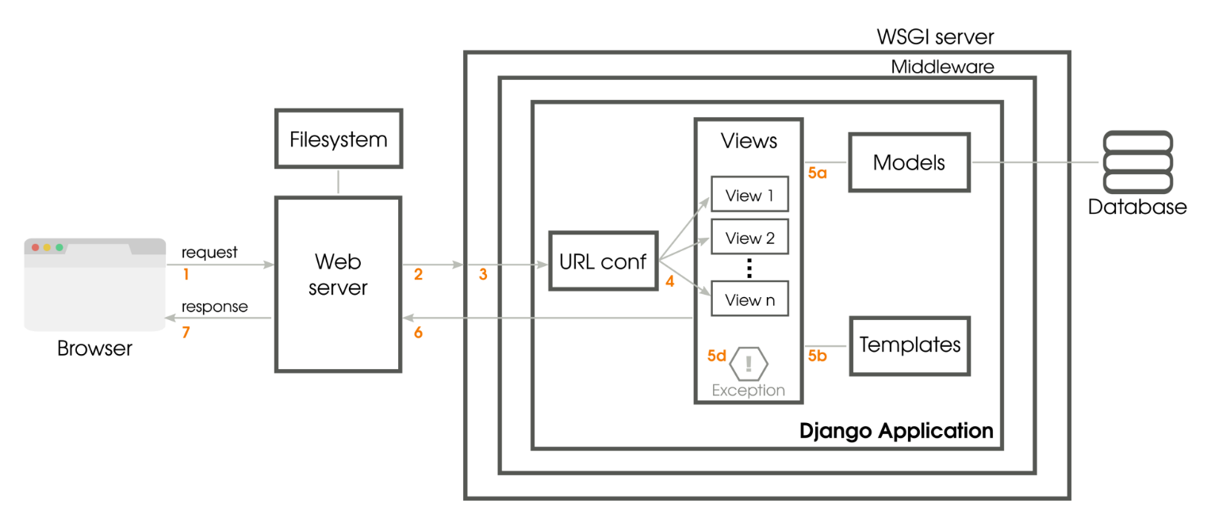

The system architecture of a Django web application typically follows the Model-View-Controller (MVC) architectural pattern, where Django introduces its own flavor known as Model-View-Template (MVT). Below is an overview of the system architecture of a Django framework:

## 2.2 Django System Architecture:

### 1. **Client-Side:**

### **Web Browser:**

* + Renders HTML, CSS, and JavaScript.
  + Handles user interactions and sends HTTP requests to the Django server.

### 2. **Server-Side:**

### **Web Server (e.g., Nginx or Apache):**

* Serves static files (CSS, JavaScript, images).
* Manages SSL/TLS termination for secure communication.
* Forwards dynamic requests to the Django application server.

### **Django Application Server (e.g., Gunicorn or uWSGI):**

* Executes the Django web application.
* Manages multiple worker processes to handle concurrent requests.
* Communicates with the web server using WSGI (Web Server Gateway Interface).

### 3. Django Framework Components (MVT):

### **Models:**

* Represents the data structure of the application.
* Defines database schema and relationships.
* Utilizes Django ORM (Object-Relational Mapping) for database interactions.

### **Views:**

* Handles the application's business logic.
* Receives requests from the client, processes data, and returns responses.
* Interacts with models to fetch or update data.

### **Templates:**

* Responsible for generating HTML dynamically.
* Embeds Python-like code to create dynamic content.
* Renders the final HTML displayed to the user.

### 4. **Database:**

### **Database Management System (DBMS):**

* Django supports various databases such as PostgreSQL, MySQL, SQLite, and Oracle.
* Interacts with the database using Django ORM.
* Manages data persistence and retrieval.

### 5. **Middleware:**

### **Django Middleware:**

* Components that process requests and responses globally before reaching views or after leaving views.
* Examples include authentication middleware, session middleware, and CSRF protection middleware.

### 6. URL Dispatcher:

### **URLconf (URL Configuration):**

* Maps URLs to view functions.
* Decides which view function to call based on the URL pattern.

### 7. **Settings:**

### **Django Settings:**

* Configures the behavior of the Django application.
* Includes database settings, middleware configurations, security settings, etc.

### 8. **Static Files and Media:**

### **Static Files:**

* CSS, JavaScript, images, and other files served directly by the web server.
* Managed by the **STATICFILES_DIRS** setting.

### **Media Files:**

* User-uploaded files (images, documents).
* Managed by the **MEDIA_ROOT** and **MEDIA_URL** settings.

## Interaction Flow:

1. The client sends an HTTP request to the web server.
2. The web server forwards dynamic requests to the Django application server.
3. Django's URL dispatcher determines the appropriate view function based on the URL.
4. The view function processes the request, interacts with models if needed, and returns a response.
5. The template engine renders dynamic content, creating the final HTML.
6. The response is sent back to the client for display in the web browser.

## 2.3 Django ORM Architecture:

### 1. **Models:**

### **Model Classes:**

* Represent database tables and define the structure of the data.
* Subclass of **django.db.models.Model**.
* Fields in the model class map to columns in the database table.

### **Field Types:**

* Django provides various field types (CharField, IntegerField, DateField, etc.) to define the type of data a field can hold.

### **Model Relationships:**

* Define relationships between models (ForeignKey, OneToOneField, ManyToManyField).
* Enable the creation of complex data structures and associations between different models.

### 2. **Database API:**

### **QuerySets:**

* Abstraction over SQL queries.
* Represent a collection of database queries that can be filtered, sliced, and generally manipulated.
* Lazily evaluated, meaning the actual database query is executed only when necessary.

### **Manager:**

* An interface for database query operations on model instances.
* Each model has a default manager (**objects**) that provides common database operations like **create()**, **filter()**, **get()**, etc.

### 3. **Database Backends:**

### **Database Engine:**

* Django supports multiple database engines, including PostgreSQL, MySQL, SQLite, and Oracle.
* The **DATABASES** setting in Django's configuration specifies the database connection details.

### **Database Migrations:**

* Django provides a migration framework for managing changes to the database schema.
* Migrations are Python files that define changes to the models and are applied sequentially to keep the database schema in sync with the code.

### 4. **Model Instances:**

### **Object-Relational Mapping:**

* Each instance of a model represents a row in the corresponding database table.
* Fields in the model map to columns, and attributes of the instance represent field values.

### **CRUD Operations:**

* Create: **Model.objects.create()**
* Read: **Model.objects.filter()**, **Model.objects.get()**
* Update: **instance.save()**
* Delete: **instance.delete()**

### 5. **Model Forms:**

### **ModelForms:**

* Automatically generate HTML forms based on model definitions.
* Simplify the process of creating, updating, and validating model instances through web forms.

### 6. **Signals:**

### **Django Signals:**

* Allow decoupled applications to get notified when certain actions occur elsewhere in the application.
* Useful for triggering additional logic or processes when specific events, such as saving a model instance, occur.

## Interaction Flow:

### **Model Definition:**

* Define models by creating Python classes that subclass **django.db.models.Model**.
* Specify fields, relationships, and any additional metadata.

### **Database Schema Creation:**

* Run **python manage.py makemigrations** to generate migration files based on model changes.
* Run **python manage.py migrate** to apply the migrations and create or update the database schema.

### **Querying and Manipulating Data:**

* Use the model's manager (**objects**) to perform CRUD operations on the database.
* Construct QuerySets to filter, sort, and retrieve data from the database.

### **Forms and Validation:**

* Utilize ModelForms for creating HTML forms based on model definitions.
* Leverage Django's built-in form validation to ensure data integrity.

### **Signals and Hooks:**

* Implement signals to execute additional logic or actions when certain events occur, such as saving a model instance.

## Benefits of Django ORM:

Abstraction of SQL: Developers work with Python code instead of raw SQL queries.

Portability: Applications can easily switch between different database backends.

Consistency: Ensures that the database schema matches the codebase, reducing inconsistencies.

Django's ORM simplifies database interactions and provides a convenient way to work with databases, making it a powerful and integral part of Django's overall architecture.

Top of Form

# 2.4 Data Base

Django web application with PostgreSQL as the RDBMS managed by psycopg2, the database section outlines the structure and organization of data within the system.

### Entities and Attributes:

* + - Identify main entities (e.g., User, Post, Comment) and define their attributes.

### Relationships:

* + - Define relationships between entities, specifying cardinality and connections.

### Tables and Fields:

* + - Map entities to PostgreSQL tables and define fields (columns) for attributes.

### Primary and Foreign Keys:

* + - Specify primary keys for unique record identification.
    - Use foreign keys for establishing relationships between tables.

### Indexes:

* Identify columns for indexing to optimize query performance.

### Constraints:

* + - Define constraints to ensure data integrity (e.g., unique constraints, check constraints).

### Normalization and Denormalization:

* + - Apply normalization techniques to organize data efficiently.
    - Consider denormalization for specific performance scenarios.

### Psycopg2 Integration:

* Specify psycopg2 as the PostgreSQL adapter in Django settings.
* Configure database connection parameters.

### Considerations:

* Plan for transaction management to ensure ACID properties.
* Outline data migration strategies.
* Implement security measures for sensitive data.
* Establish backup and recovery procedures.
* Consider scalability requirements.

# 

### 

# 2.5 Web Server

The web server section handles the communication between clients and the Django application. Nginx is used as the front-end server to serve static files, handle SSL termination, and forward dynamic requests to the Gunicorn application server.

### **Components:**

### **Nginx:**

* Serves as the front-end server.
* Manages SSL termination.
* Handles static file serving.
* Acts as a reverse proxy to forward requests to Gunicorn.

### **Gunicorn:**

* Acts as the application server for Django.
* Processes dynamic requests forwarded by Nginx.

### **Configuration Steps:**

### **Nginx Configuration:**

### **SSL Configuration:**

* + - Generate or obtain SSL certificates.
    - Configure Nginx to use SSL with the obtained certificates.
    - Set up SSL protocols and ciphers for security.

### **Static File Serving:**

* + - Define the root directory for serving static files.
    - Configure Nginx to handle requests for static content directly.

### **Reverse Proxy for Django:**

* + - Configure Nginx to act as a reverse proxy for Gunicorn.
    - Forward requests to the Gunicorn application server.

### **Load Balancing (Optional):**

* + - Implement load balancing if multiple Gunicorn instances are used.
    - Adjust Nginx configuration to distribute requests among Gunicorn instances.

## **Gunicorn Configuration:**

### **Bind Address and Port:**

* Configure Gunicorn to bind to a specific address and port.
* Ensure Nginx forwards requests to the correct address and port.

### **Number of Workers:**

* Set the number of worker processes based on server resources.
* Consideration for optimal performance and resource utilization.

### **Security Configuration:**

* Limit access to Gunicorn to trusted IP addresses if applicable.
* Enable Gunicorn's security features, such as secure headers.

## **Security Considerations:**

### **Nginx Security:**

### **Firewall (iptables):**

* Configure iptables rules to allow traffic on necessary ports (e.g., 80, 443).
* Restrict access to only trusted IP addresses.
* Implement rate limiting to mitigate potential DDoS attacks.

### **SSL Security:**

* Ensure SSL protocols and ciphers are configured securely.
* Regularly update SSL certificates.
* Implement HTTP Strict Transport Security (HSTS).

### **Error Handling:**

* Customize error pages to avoid exposing sensitive information.
* Log errors securely.

## **Gunicorn Security:**

### **Access Control:**

* Restrict access to Gunicorn to trusted IP addresses.
* Avoid exposing Gunicorn to the public network.

### **Worker Processes:**

* Set appropriate values for the number of worker processes.
* Monitor and adjust based on server load and performance.

### **Security Headers:**

* Enable security headers in Gunicorn to enhance security.
* Implement measures to prevent cross-site scripting (XSS) attacks.

## **Logging and Monitoring:**

### **Nginx Logging:**

* Configure Nginx to log access and error information.
* Store logs securely and regularly review them.

### **Gunicorn Logging:**

* Enable Gunicorn logging for access and error information.
* Integrate with a logging system for centralized monitoring.

# 2.6 Application Server

The application server section is responsible for executing the Django web application. Gunicorn (Green Unicorn) is chosen as the application server to handle dynamic requests from clients.

## **Components:**

### **Gunicorn (Green Unicorn):**

* Acts as the application server for Django.
* Manages multiple worker processes.
* Communicates with the Django web application.

## **Gunicorn Configuration:**

### **Bind Address and Port:**

* Configure Gunicorn to bind to a specific address and port.
* Ensure it matches the address and port configured in Nginx.

### **Number of Workers:**

* Set the number of worker processes based on server resources.
* Consideration for optimal performance and resource utilization.

### **Concurrency Model:**

* Choose an appropriate concurrency model (sync, async) based on application requirements.
* Adjust the number of worker processes accordingly.

### **Worker Class:**

* Select a worker class suitable for the application's needs (e.g., sync, gevent).
* Configure worker class parameters.

### **Request Timeout:**

* Set the maximum allowed time for a request to be processed.
* Prevents long-running requests from affecting server performance.

### **Security Configuration:**

* Limit access to Gunicorn to trusted IP addresses if applicable.
* Enable Gunicorn's security features, such as secure headers.

### **Logging Configuration:**

* Configure Gunicorn logging settings for access and error logs.
* Determine log file locations and log formats.

## **Security Considerations:**

### **Access Control:**

* Restrict access to Gunicorn to trusted IP addresses.
* Avoid exposing Gunicorn to the public network.

### **Worker Processes:**

* Set appropriate values for the number of worker processes.
* Monitor and adjust based on server load and performance.

### **Security Headers:**

* Enable security headers in Gunicorn to enhance security.
* Implement measures to prevent cross-site scripting (XSS) attacks.

## **Monitoring and Performance:**

### **Performance Tuning:**

* Adjust Gunicorn settings based on server hardware and application load.
* Monitor CPU and memory usage to optimize configuration.

### **Health Checks:**

* Implement health checks to monitor the status of Gunicorn workers.
* Ensure Gunicorn automatically restarts workers in case of failures.

# 2.7 Logging and Monitoring

## Access Logs:

### Configuration:

Define the access log format in Nginx configuration.

Example: log_format main '$remote_addr - $remote_user [$time_local] "$request" '

'$status $body_bytes_sent "$http_referer" '

'"$http_user_agent" "$http_x_forwarded_for"';

access_log /var/log/nginx/access.log main;

### Information Logged:

IP address, user identity, date, request, status, bytes sent, referrer, user agent, and forwarded-for header.

### Error Logs:

### Configuration:

Specify the error log file and logging level.

Example: error_log /var/log/nginx/error.log error;

## Gunicorn Logging

### Access Logs:

### Configuration:

Specify the access log format and file.

Example: gunicorn myapp.wsgi:application --access-logfile /var/log/gunicorn/access.log --access-logformat '%(h)s %(l)s %(u)s %(t)s "%(r)s" %(s)s %(b)s "%(f)s" "%(a)s"'

### Information Logged:

IP address, user identity, date, request, status, bytes sent, referrer, user agent.

## Error Logs:

### Configuration:

Specify the error log file.

Example: gunicorn myapp.wsgi:application --error-logfile /var/log/gunicorn/error.log

## Gunicorn Monitoring:

### Gunicorn StatsD Integration:

### Configuration:

Install the **statsd** package. Configure Gunicorn to send metrics to a StatsD server.

Example: gunicorn myapp.wsgi:application --statsd-host=localhost:8125 --statsd-prefix=myapp

### Monitoring:

Set up a StatsD server and use monitoring tools like Grafana for visualization.

## Log Rotation:

## Nginx:

### Configuration:

Configure log rotation using tools like **logrotate**.

Example : /var/log/nginx/*.log {

daily

missingok

rotate 14

compress

delaycompress

notifempty

create 0640 www-data adm

sharedscripts

postrotate

[ -f /var/run/nginx.pid ] && kill -USR1 `cat /var/run/nginx.pid`

endscript

}

## Gunicorn:

### Configuration:

Implement log rotation using **logrotate** or similar tools.

Example: /var/log/gunicorn/*.log {

daily

missingok

rotate 14

compress

delaycompress

notifempty

create 0640 www-data adm

sharedscripts

postrotate

/bin/kill -s HUP `cat /var/run/gunicorn/myapp.pid 2>/dev/null` 2>/dev/null || true

endscript

}

# 3. Module Wise Details

## 3.1 User Registration

### Custom Account Model:

* The user account model includes fields such as email, name, mobile, country, status flags (is_active, is_staff), and timestamps (created, updated).
* It uses a custom manager **(CustomAccountManager**) to handle the creation of regular users and superusers.

### User Registration Form (UserAddressForm):

* This form, based on **forms.ModelForm**, is designed for capturing user address details.
* It includes fields like full name, phone, address lines, town/city, and postcode.
* The form's constructor **(__init__)** updates widget attributes for styling and placeholder text.

### User Registration View (account register):

* The registration view checks if the user is already authenticated; if so, it redirects to the dashboard.
* If the request method is POST, it processes the registration form.
* Upon successful form validation, a new user instance is created, and an activation email is sent.
* The user is marked as inactive until they activate their account through the received email.
* A confirmation page is rendered for successful registration.

### User Activation View (account_activate):

* This view is responsible for activating a user's account based on a unique ID (UID) and an activation token.
* It decodes the UID, retrieves the corresponding user from the database, and checks the validity of the activation token.
* If successful, the user is marked as active, logged in, and redirected to the dashboard.
* If unsuccessful, it renders a page indicating that the activation is invalid.

### URL Patterns:

* The URL patterns are configured to handle paths such as login, logout, register, and account activation.
* The login and logout views are provided by Django's authentication views (**LoginView, LogoutView).**
* Custom templates and forms are used for the login view.
* The registration and activation views are associated with specific paths.

## 3.2 Book Catalogue and Filtering

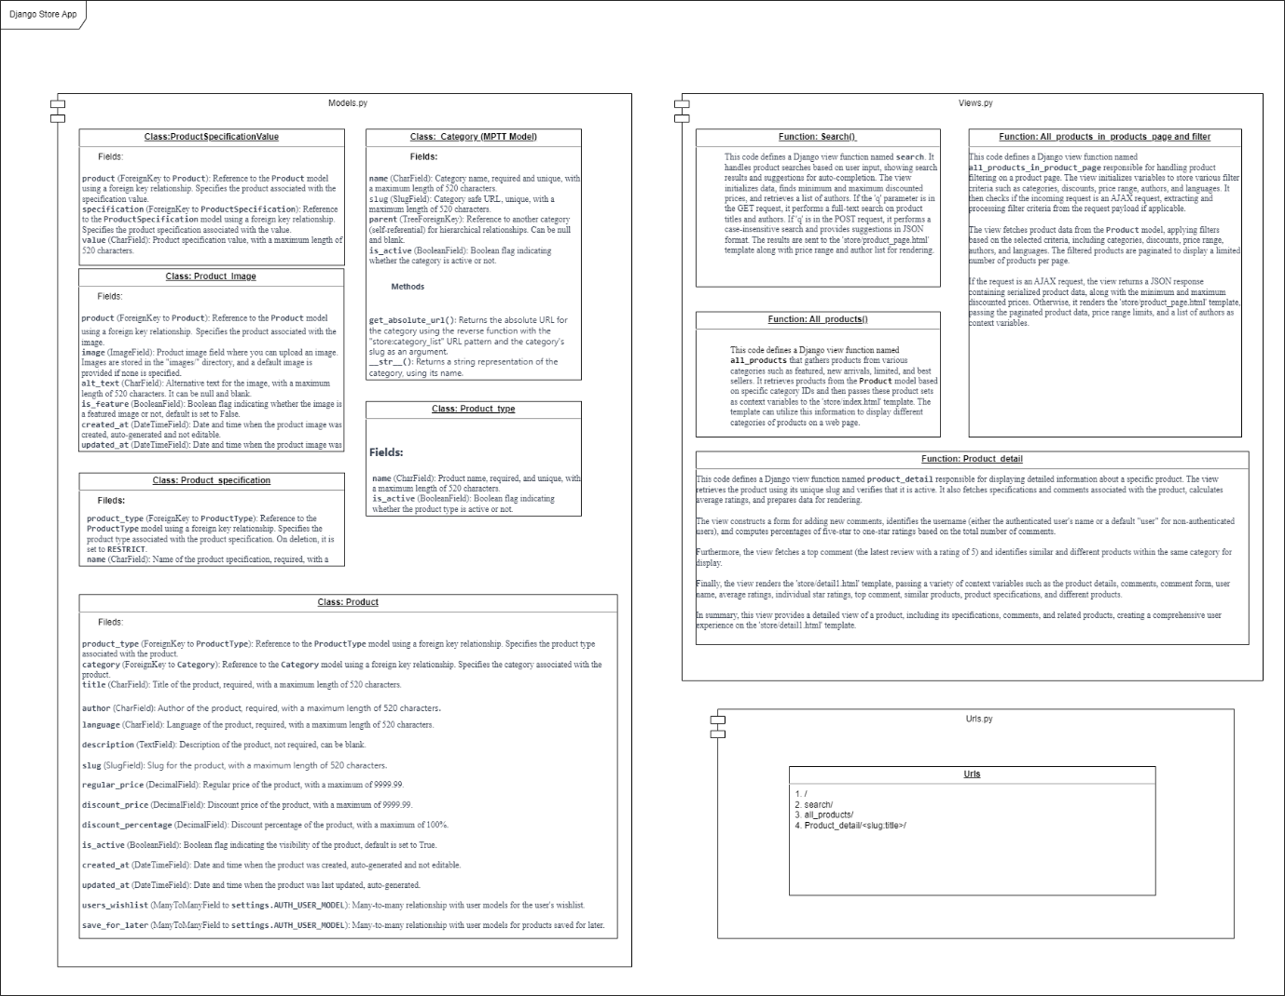

### Let's overview how these components are connected and the relationships between them:

### Models:

* **Category:** Represents different categories of products.
* **Product Type:** Represents various types or categories of products.
* **Product Specification:** Contains product specifications or features for different product types.
* **Product Specification Value:** Holds individual product specifications or features.
* **Product:** Represents individual products for sale, associated with a specific product type, category, and specifications.
* **Product Image:** Stores images associated with each product.

### Views:

* **all products:** Displays products from various categories (featured, new arrivals, limited, best sellers).
* **search:** Handles product searches, providing search results and suggestions for auto-completion.
* **All products in product page:** Manages product filtering on a product page, returning filtered results and handling AJAX requests for dynamic updates.
* **Product detail:** Displays detailed information about a specific product, including specifications, comments, and related products.

### URL Patterns:

* **' '**: Maps to the **all_products** view, displaying products from various categories.
* **'search/'**: Maps to the **search** view, handling product searches.
* **'product_page'**: Maps to the **all_products_in_product_page** view, managing product filtering on a product page.
* **'addcomment/'**: Maps to the **addcomment** view (not provided in the provided code).
* **'<slug:slug>':** Maps to the **product_detail** view, displaying detailed information about a specific product based on its slug.

### Connections and Relationships:

* Products (**Product**) are associated with categories **(Category),** types (ProductType), and have specifications (**ProductSpecification)** and images (**ProductImage**).
* Product details are displayed in the **product_detail** view, including related specifications, comments, and similar/different products.
* The **all_products_in_product_page** view handles dynamic product filtering based on user-selected criteria, interacting with the **Product** model and returning filtered results.

In summary, the provided code establishes a comprehensive structure for managing and displaying products, handling searches, and providing detailed information about individual products. The URL patterns define how different views are accessed within the Django web application.

## 3.3 Comments System

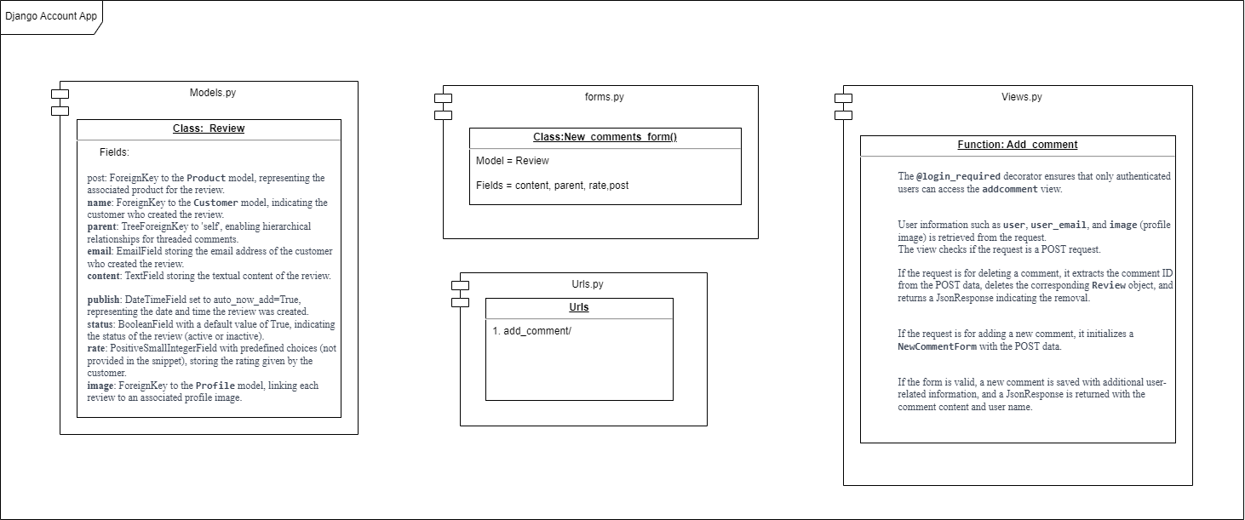

### **Models (models.py):**

* The **Review** model represents a review with hierarchical capabilities using the MPTT library.
* It has fields for the associated product **(post),** customer **(name)**, parent comment **(parent),** email, content, publication timestamp **(publish),** status, rating **(rate),** and a profile image **(image).**

### **Forms (forms.py):**

* The **NewCommentForm** is a model form based on the **Review** model.
* It includes fields for the comment content (**content**), parent comment **(parent),** rating **(rate),** and associated product (**post**).
* The **parent** field is a **TreeNodeChoiceField** allowing selection of a parent comment for threading.
* The form has customizations for widget attributes and a save method that rebuilds the MPTT tree after saving a new comment.

### **Views (views.py):**

* The **addcomment** view is decorated with **@login_required**, ensuring only authenticated users can access it.
* Retrieves user information such as the user object, user email, and user profile image.
* Handles both comment creation and deletion based on the received POST data.
* If the request is for comment deletion, it extracts the comment ID, deletes the corresponding **Review** object, and returns a JsonResponse indicating the removal.
* If the request is for adding a new comment, it initializes the **NewCommentForm** with the POST data.
* Validates the form, saves the comment with additional user-related information, and returns a JsonResponse with the comment content and user name.

### Relationships and Django Functionality:

### **Model Relationships:**

* **Review** model has ForeignKey relationships with the **Product (as post),** **Customer (as name)**, and **Profile models (as image).**
* **Review** model has a TreeForeignKey relationship with itself (as **parent**) to support hierarchical comments.

### **Django Functionality:**

### **MPTT Library:**

* The **Review** model uses the Modified Preorder Tree Traversal (MPTT) library to represent hierarchical data efficiently.
* MPTT allows for easy retrieval of hierarchical data and is often used for threaded comments.

### **Django Forms:**

* The **NewCommentForm** is a Django model form based on the **Review** model.
* It handles form rendering, validation, and saving, including specific customizations for widget attributes and the save method for MPTT tree rebuilding.

### **Django Views:**

* The **addcomment** view is decorated with **@login_required**, ensuring that only authenticated users can access it.
* Handles both comment creation and deletion based on the received POST data.
* Uses the **NewCommentForm** for comment creation, validating the form, and saving the comment with additional user-related information.
* Returns JsonResponses to handle AJAX requests, providing feedback on comment creation and deletion.

This system is designed to manage product reviews with hierarchical, threaded comments, and associated user and product information. The MPTT library facilitates efficient querying of hierarchical data, and Django's forms and views handle the creation and deletion of comments, ensuring proper validation and user authentication. The JsonResponse responses are used for AJAX interactions in the frontend.

## 3.4 Basket or Cart System

## 

## Basket.py

### Class Overview:

### **Initialization:**

The class is initialized with a request object, presumably representing a user's HTTP request.

It uses the Django session to store and retrieve basket-related information.

### **Adding Items (**add **method):**

The **add** method allows for adding or updating items in the basket.

It uses the product ID as the key and stores information like price and quantity in the session.

### **Iteration (**__iter__ **method):**

Implements an iterator to iterate through items in the basket.

Retrieves product information from the database using the stored product IDs in the session.

Calculates total prices for each item.

### **Length Calculation (**__len__ **method):**

Returns the total quantity of items in the basket.

### **Updating Items (**update **method):**

Allows for updating the quantity of items in the basket.

### **Price Calculations:**

**get_subtotal_price** calculates the subtotal price of items in the basket.

**get_total_price** calculates the total price, considering the subtotal and delivery price (if applicable).

**get_delivery_price** retrieves the delivery price from the session.

### **Deletion (**delete **method):**

Deletes a specific item from the basket.

### **Delivery Price Update (**basket_update_delivery **method):**

Updates the total price considering a new delivery price.

### **Basket Clearing (**clear **method):**

Clears the entire basket by removing it from the session.

### Saving (save method):

Marks the session as modified to ensure changes are saved.

## Connections and Relationships:

### **Session and Settings:**

* + The class uses the Django session to store and retrieve basket-related information.
  + The session key is specified in the Django settings (**settings.BASKET_SESSION_ID**).

### **Product Model:**

* The class interacts with the **Product** model to retrieve detailed information about products in the basket.

### **DeliveryOptions Model:**

* + The class interacts with the **DeliveryOptions** model to retrieve delivery prices if a purchase is present in the session.

### **Overall Workflow:**

* + The class manages the interactions between the user's shopping basket, product details, and potential delivery options.

## Model Relationships:

### Product **Model:**

* + The base model representing products.
  + No explicit relationships with other models are described in the provided code, but it can be assumed that products may be associated with other models like categories, tags, etc.

### Basket **Model:**

* + No explicit model definition is provided, but it's assumed that the **Basket** class manages the user's shopping basket and interacts with the **Product** model.
  + The **Basket** class likely handles the addition, deletion, and updating of items in the basket.

### Save_For_Later **Model:**

* + Represents items saved for later by users.
  + Foreign Key to **Product** model: **product = models.ForeignKey(Product, on_delete=models.CASCADE)**.
  + Foreign Key to **Customer** model for the user: **user = models.ForeignKey(Customer, on_delete=models.CASCADE)**.
  + The **product** and **user** fields establish relationships with the **Product** and **Customer** models.

## View Interactions:

### basket_summary **View:**

* + Retrieves and displays information about the user's shopping basket and save-for-later items.
  + Handles product search, likely interacting with the **Product** model.

### basket_add **View:**

* + Adds products to the user's shopping basket.
  + Interacts with the **Basket** class for adding items and potentially updates the **Product** model.

### basket_delete **View:**

* + Deletes specified products from the user's shopping basket.
  + Interacts with the **Basket** class for removing items and potentially updates the **Product** model.

### basket_update **View:**

* + Updates the quantity of specified products in the user's shopping basket.
  + Interacts with the **Basket** class for updating items and potentially updates the **Product** model.

### add_to_save_for_later **View:**

* + Adds a product to the user's save-for-later list.
  + Creates a **Save_For_Later** entry and interacts with the **Basket** class for deleting the product from the basket.

### remove_save_for_later **View:**

* + Removes a product from the user's save-for-later list.
  + Interacts with the **Save_For_Later** model for deleting the entry.

## Workflow:

### **Basket Workflow:**

* + Users add, update, or remove items from their shopping basket using the **Basket** class.
  + Views like **basket_add**, **basket_delete**, and **basket_update** interact with the **Basket** class for these operations.

### **Save-for-Later Workflow:**

* + Users add or remove items from the save-for-later list using the **Save_For_Later** model.
  + Views like **add_to_save_for_later** and **remove_save_for_later** interact with the **Save_For_Later** model for these operations.

### **Product Interaction:**

* + Views that modify the basket may interact with the **Product** model to update information or quantities.

## Overall Connection:

* The views orchestrate interactions between the **Basket**, **Save_For_Later**, and **Product** models to manage the user's shopping experience, including adding, updating, and removing items from the shopping basket and save-for-later list.
* The models represent the essential entities (products, shopping basket, save-for-later items), and the views act as controllers, handling user requests and modifying data accordingly.

## 3.5 Add to Wishlist

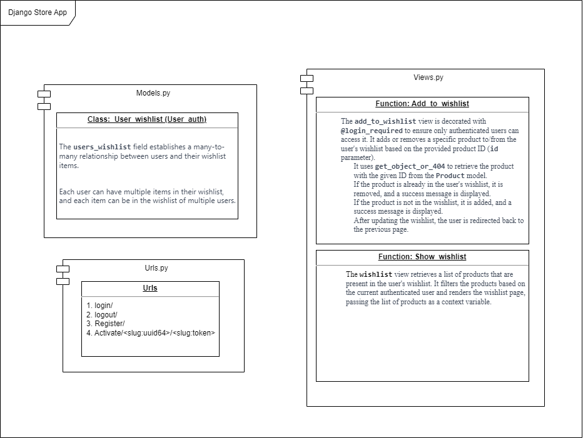

## 3.6 Book Recommendation

### Model Definitions:

* **Product**: Represents a book with fields such as **title**, **author**, and **genre**. Additional fields for other relevant book information can be added.
* **User**: Represents a user with a **username**. Additional user-related fields can be included as needed.
* **Recommendation**: Represents a user's recommendation for a particular book. It includes a foreign key relationship with both the **User** and **Book** models, along with fields for **rating** and **review**. Other recommendation-related fields can be added based on requirements.

### Functions:

* **get_user_recommendations(user)**: Retrieves book recommendations for a specific user by querying the **Recommendation** model based on the user's ID.
* **add_recommendation(user, book, rating, review)**: Adds a new recommendation to the system. It creates a new **Recommendation** object with the provided user, book, rating, and review, and saves it to the database.
* **get_top_rated_books(limit=5)**: Retrieves the top-rated books based on average ratings from user recommendations. It uses Django's queryset annotations to calculate the average rating and orders the books accordingly.

### Usage Considerations:

* The models and functions provide a foundation for managing book data, user information, and book recommendations.
* Additional features, such as user authentication, error handling, and more detailed book information, can be incorporated based on the specific requirements of the web application.
* This design assumes a basic one-to-many relationship between users and recommendations and books and recommendations. Adjustments may be needed for more complex relationships or additional features.

## 3.7 Adding User Address

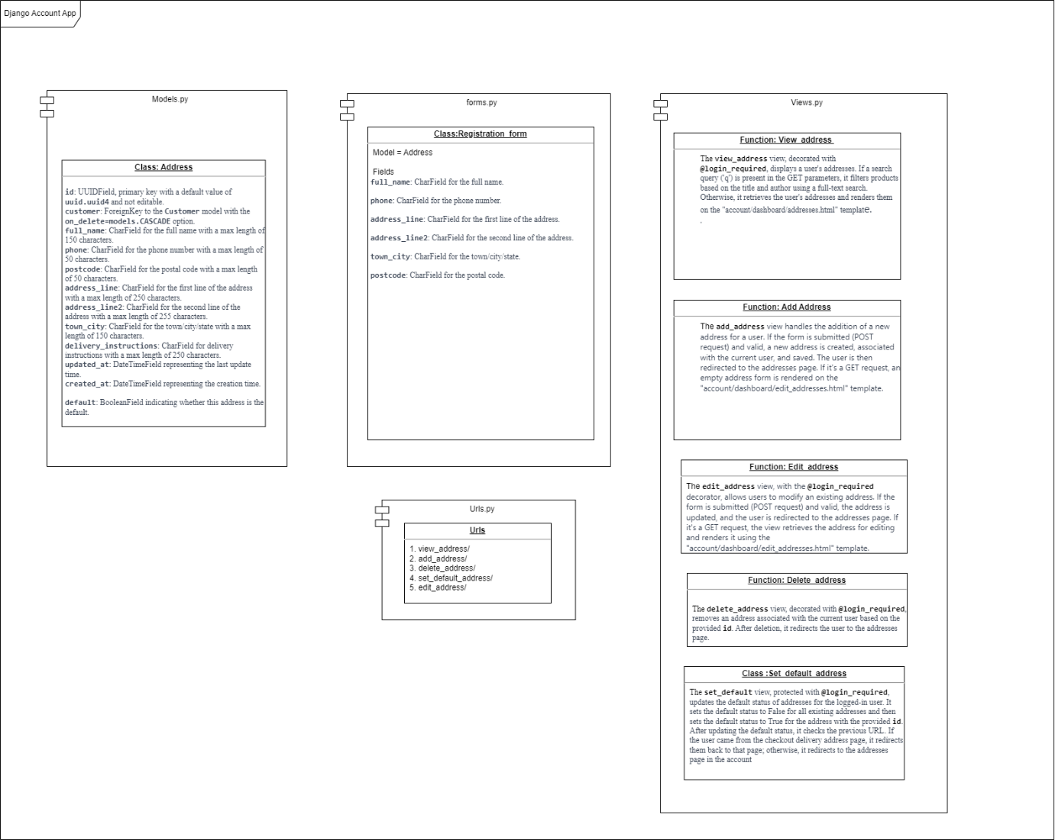

## Address Model:

* Represents user addresses with fields such as **full_name**, **phone**, **postcode**, etc.
* Each address is associated with a specific **Customer** through a foreign key.

## UserAddressForm:

* A Django ModelForm for the **Address** model, specifying fields and providing customization for rendering.

## add_address View:

* Handles the addition of a new address for a user.
* Validates form data, associates the address with the current user, and saves it.
* Redirects to the addresses page upon successful addition.

## view_address View:

* Displays user addresses.
* If a search query is present, filters and displays products based on a full-text search.
* Renders the addresses on the "account/dashboard/addresses.html" template.

## edit_address View:

* Allows users to modify an existing address.
* Retrieves the address for editing and updates it based on the form submission.
* Renders the address form on the "account/dashboard/edit_addresses.html" template.

## delete_address View:

* Removes an address associated with the current user based on the provided **id**.
* Redirects the user to the addresses page after deletion.

## set_default View:

* Updates the default status of addresses for the logged-in user.
* Sets the default status to False for all existing addresses and True for the selected address.
* Checks the previous URL and redirects accordingly, either to the checkout delivery address page or the addresses page in the account.

## Relationship:

* add_address, view_address, edit_address, delete_address, and set_default views collectively handle different aspects of managing user addresses.
* They share the Address model and utilize the UserAddressForm form for data validation and rendering.
* implying a potential relationship between user addresses and products.
* set_default indicates address preferences, possibly relevant for checkout processes.

## 3.8 Book Purchase (Buy)

Let's provide a brief overview of the main functionalities:

### Order Model:

* Represents an order with various details such as user, full name, phone, delivery instructions, total paid, order key, billing status, and order status.

### DeliveryOptions Model:

* Represents different delivery options with fields like delivery name, price, method, timeframe, window, order, and active status.

### PaymentSelections Model:

* Represents different payment selections with a field for the name and an active status.

### OrderItem Model:

* Represents items within an order, associated with a product, order, price, and quantity.

### ReturnPolicy Model:

* Represents the return policy for an order, associated with an order, return reason, return date, refund amount, and acceptance status.

### Views and URL Patterns:

* **add_address, view_address, edit_address, delete_address**: Manage user addresses.
* **set_default:** Sets the default status of addresses for the logged-in user.
* add: Handles the addition of a new address to the user's account.
* **payment_confirmation:** Updates the billing status of an order to indicate payment confirmation.
* **user_orders:** Retrieves and returns a queryset of orders associated with the currently authenticated user.
* **return_book** and **return_book_submit:** Handle the return process for a specific order.
* **payment_selection**: Renders the payment selection page during the checkout process.
* **/deliverychoices, /basket_update_delivery/, /delivery_address/, /set_delivery_address/, /payment_selection/, /payment_selection/webhook/, /payment_successful/:** Define URL patterns for different steps in the checkout process.

### Connections and Relationships:

* There's a clear connection between the models (e.g., **Order, OrderItem, ReturnPolicy)** and the views handling user actions and order processing.
* The views seem to facilitate user interactions, including managing addresses, processing orders, and handling returns.
* There is integration with a payment gateway (Stripe) for handling payment-related events asynchronously.
* The URL patterns define the flow through the checkout process, starting from delivery choices to payment and handling webhook events.

### Functions Overview

### add_address:

* Handles the addition of a new address for the authenticated user.
* Validates form data, associates the address with the current user, and saves it.
* Redirects to the addresses page upon successful addition.

### view_address:

* Displays user addresses.
* If a search query is present, filters and displays products based on a full-text search.
* Renders the addresses on the "account/dashboard/addresses.html" template.

### edit_address:

* Allows users to modify an existing address.
* Retrieves the address for editing and updates it based on the form submission.
* Renders the address form on the "account/dashboard/edit_addresses.html" template.

### delete_address

* Removes an address associated with the current user based on the provided **id**.
* Redirects the user to the addresses page after deletion.

### set_default

* Updates the default status of addresses for the logged-in user.
* Sets the default status to False for all existing addresses and True for the selected address.
* Checks the previous URL and redirects accordingly, either to the checkout delivery address page or the addresses page in the account.

### add:

* Processes a POST request to add items to an order.
* Checks if the order with the provided key exists; if not, creates a new order and associated order items from the basket.
* Returns a JsonResponse (content incomplete).

### payment_confirmation

* Updates the billing status of an order with a specified order key to **True**.
* Likely used to indicate that the payment for the corresponding order has been confirmed.

### user_orders

* Retrieves and returns a queryset of orders associated with the currently authenticated user.
* Filters orders based on user ID and billing status.

### return_book

* Handles the return process for a specific order.
* Checks the return policy status and renders success or rejection messages accordingly.
* Renders the 'account/dashboard/return.html' template for submitting return requests.

### return_book_submit

* Handles the submission of a return request for a specific order.
* Validates the form data and creates a new **ReturnPolicy** instance associated with the order.
* Renders success or failure messages on the 'account/dashboard/success.html' template.

### payment_selection

* Renders the payment selection page during checkout.
* Retrieves default addresses, performs a product search if there's a query, and initializes a Stripe PaymentIntent.
* Renders the 'checkout/payment_selection.html' template with necessary data.

These functions collectively manage various aspects of the e-commerce platform, including user addresses, order processing, returns, and payment selection during the checkout process.

## 3.9 Stripe API Payment

The **stripe_webhook** view is a Django view function that handles incoming webhook events from the Stripe API, particularly events related to payment processing. Here's a description of the code:

### @csrf_exempt:

* Decorator to exempt the view from Cross-Site Request Forgery (CSRF) protection. Webhooks are typically sent by Stripe directly, and CSRF protection is not necessary in this context.

### payload = request.body:

* Retrieves the raw payload (JSON data) from the incoming HTTP request.

### event = None:

* Initializes a variable **event** to store the parsed Stripe event.

### Parsing and Handling the Webhook Event:

* try block:
* Attempts to parse the incoming payload as a Stripe event using the stripe.Event.construct_from method.
* If successful, sets the event variable with the parsed event.
* If parsing fails (ValueError), returns a 400 Bad Request HTTP response.

### Handling the Event:

* if event.type == 'payment_intent.succeeded'::
* Checks if the event type is 'payment_intent.succeeded'.
* If true, calls the payment_confirmation function, passing the client secret from the Stripe event data.
* This is likely the point where the application can confirm that a payment has succeeded and take appropriate actions.
* else block:
* Handles other event types. In this case, it simply prints an informational message about unhandled event types.

### return HttpResponse(status=200):

* Returns a 200 OK HTTP response, indicating successful processing of the webhook event.

**Description:** The **stripe_webhook** view serves as an endpoint to receive and process webhook events from the Stripe API. In this specific implementation, it focuses on handling the **'payment_intent.succeeded'** event, which signifies the successful processing of a payment. Upon receiving this event, the view triggers the **payment_confirmation** function, suggesting that it might update the billing status or perform other actions related to order processing.

Webhooks are a crucial part of integrating with payment gateways like Stripe, allowing the application to respond to events in real-time and keep its data synchronized with the payment provider. CSRF protection is disabled **(@csrf_exempt)** because Stripe sends requests directly to this endpoint, and the application must be able to receive them without CSRF validation.

## 3.10 Order Tracking System

### 1. Order Model:

* **Purpose:** Defines the database structure for storing order-related information.
* **Attributes:**
* Order ID
* User ID (Foreign Key)
* Timestamps (created, updated)
* Order Status (Processing, Shipped, Out for Delivery, Delivered)
* Shipping Details (Address, Contact Information)
* Payment Status
* Tracking Number

### 2. Order Tracking Module:

* **Purpose:** Manages the tracking of orders and their statuses.
* **Functions:**
* Track Order Status: Updates and retrieves the current status of an order.
* Notifications: Sends notifications to users when the order status changes.

### 3. Notifications Module:

* **Purpose:** Handles the delivery of real-time notifications to users.
* **Functions:**
* Sends notifications for order status changes.
* May include tracking numbers, expected delivery dates, and any issues.

### 4. Dashboard Module:

* **Purpose:** Provides an overview of all orders for users.
* **Features:**
* Displays a summary of orders with their current statuses.
* Allows users to click on an order to view detailed information.

### 5. External APIs Integration Module:

* **Purpose:** Connects the web app with external APIs for real-time tracking data.
* **Integrations:**
* Shipping Carrier APIs: Retrieves live tracking information.

### 6. Event-Driven Architecture Module:

* **Purpose:** Enables real-time updates based on specific events.
* **Components:**
* Event Handlers: React to events such as order processing and delivery.
* Event Emitters: Trigger events in the system.

### 7. User Interface (UI) Module:

* **Purpose:** Designs a user-friendly interface for order tracking.
* **Aspects:**
* Responsive Design: Ensures accessibility across devices.
* Clear Communication: Clearly communicates the meaning of each order status.
* Interactive Elements: Enables users to navigate and interact effortlessly.

### 8. Webhook Module:

* **Purpose:** Handles incoming webhook events from external services.
* **Functions:**
* Receives and processes events from shipping carriers.
* Triggers relevant actions based on event types (e.g., order shipped).

### 9. Database Schema Module:

* **Purpose:** Defines the database structure for storing order-related data.
* **Components:**
* Tables for Orders, User Information, Notifications, etc.
* Relationships between tables (Foreign Keys).

### 10. Benefits and Future Enhancements Module:

* **Purpose:** Lists the advantages of the Order Tracking System and suggests areas for improvement.
* **Aspects:**
* Enhanced Customer Satisfaction: Detailed tracking fosters trust and satisfaction.
* Operational Efficiency: Real-time updates streamline internal processes.
* Future Enhancements: Recommendations for additional features and improvements.
* These modules collectively form the Order Tracking System, providing users with real-time insights into the status and location of their orders within your Django Bookstore Web App.

## 3.11 Book Listing (sell)

## Overview of Sell_Old_Books Module

### sell_old_books **Model:**

* Represents old books for sale.
* Fields include details like title, price, category, images, etc.
* Defines relationships with other models using Foreign Key.

### category_list **View:**

* Displays a list of products in a specific category.
* Uses pagination for product display.
* Supports search functionality.

### home **View:**

* Renders the home page with a range of discount prices.
* Supports search functionality for all published products.

### product_detail **View:**

* Displays detailed information about a specific product.
* Calculates the average rating for the product.

### mybooks **View:**

* Displays the user's published books.
* Supports search functionality.
* Allows editing and deleting individual book listings.

### edit_books **View:**

* Allows authenticated users to edit details of a specific book listing.
* Utilizes a form for editing book details.

### delete_books **View:**

* Allows authenticated users to delete a specific book listing.

### mysoldbooks **View:**

* Displays a user's list of sold books.
* Supports search functionality.

## Important Relationships:

* **sell_old_books** has ForeignKey relationships with **OrderItem**, **Order**, and **Category**.
* **OrderItem** is associated with **Order**.

## Objectives:

## **General Objective:**

* Facilitate the buying and selling of old books through a web application.

## **Specific Objectives:**

### **Listing Books:**

* Allow users to list old books for sale (**sell_old_books**).
* Categorize books and provide search functionality.

### **User Interaction:**

* Allow users to view, edit, and delete their listed books (**mybooks, edit_books, delete_books**).

### **Sales and Tracking:**

* Display a list of sold books (**mysoldbooks**).
* Calculate average ratings for products.

### **User Experience:**

* Provide a home page (**home**) with a range of discount prices.
* Enhance search capabilities throughout the application.

## Conclusion:

The Django application aims to create a platform for users to buy and sell old books. Key features include listing books, managing user interactions, tracking sales, and ensuring an improved user experience through various views and functionalities. The defined relationships between models support the organization and retrieval of relevant data.

## 3.12 Blogs

### Post Model:

* Represents a blog post with fields such as title, content, author, timestamp, and tags.

### Relationships:

* + ForeignKey with User model for the author.
  + ManyToManyField with Tag model for categorizing posts.

### Tag Model:

* Defines categories or tags for organizing blog posts.
* Fields include the tag name.

### Relationships:

* ManyToManyField with **Post** model to associate tags with blog posts.

### Comment Model:

* + - Represents a comment on a blog post.
    - Fields include the commenter, content, timestamp, and reference to the associated post.

### Relationships:

* ForeignKey with User model for the commenter.
* ForeignKey with Post model to associate comments with blog posts.

### User Model (Extended):

* Extends the built-in **User** model to include additional fields like a profile picture, bio, etc.

### Relationships:

* + One-to-Many relationship with **Post** model for authored blog posts.
  + One-to-Many relationship with **Comment** model for posted comments.

### Views Module:

* Contains Django views for rendering blog posts, creating new posts, adding comments, etc.
* Uses Django's class-based views for efficiency and organization.
* Leverages Django's generic views for common CRUD operations.

### Forms Module:

* Provides forms for creating and editing blog posts, adding comments, etc.
* Utilizes Django's built-in form classes for easy validation and handling.

### Templates Module:

* Consists of HTML templates for rendering blog posts, post lists, comments, etc.
* Uses Django template language to dynamically display data.

### URLs Module:

* Defines URL patterns for accessing different views within the blog app.
* Includes patterns for creating, editing, deleting posts, adding comments, etc.

### Objectives:

* Allow users to create, edit, and delete blog posts.
* Enable users to categorize posts using tags.
* Facilitate commenting on blog posts.
* Provide an organized and visually appealing display of blog content.
* Ensure user authentication and authorization for post-related actions.
* Enhance user profiles with extended information.

Conclusion: The Blog App within the Django application aims to create a comprehensive platform for blogging. It focuses on user engagement, post categorization, and a seamless user experience through well-defined models, views, templates, and forms. The modular design allows for easy maintenance and scalability of the blog features.

# 4. Technology Stack

|  |  |
| --- | --- |
| **Front End** | HTML/CSS/JavaScript/AJAX/Bootstrap |
| **Backend** | Python Django |
| **Database** | Postgres SQL |
| **Deployment** | Local Linux Server |
| **Admin** | Django Admin |
| **version control** | GitHub |

# 5. Detailed Database Design

# 6. Code Structure

## Directory Structure Overview:

### Django Apps:

* account/, basket/, blog/, checkout/, core/, orders/, sellbook/, store/
* Overview: Each directory represents a Django app, encapsulating specific functionalities like user accounts, shopping basket, blog, checkout, etc.

### Static Files:

* Location: /static/
* Overview: Contains static files such as CSS, JavaScript, and other assets used in the project.

### Templates:

* Location: /templates/
* Overview: Holds HTML templates used by Django views to render dynamic content.

### Virtual Environment:

* Location: /venv/
* Overview: A virtual environment for isolating Python dependencies and project-specific packages.

### Configuration and Metadata:

* .dockerignore, .gitignore, docker-compose.yml, Dockerfile, manage.py, README.md, requirements.txt, server.py, stripe.exe
* Overview: These files manage Docker configuration, Git version control, Docker deployment, project management, documentation, dependencies, server script, and any executable files required for the project.

### HTML Files:

* Location: /html/
* Overview: Contains additional HTML files that may be used in the project.

### Logs and Media:

* logs/, media/
* Overview: Directories for storing log files and user-uploaded media files, respectively.

### Visual Studio Code Configuration:

* Location: /.vscode/
* Overview: Contains configuration files specific to Visual Studio Code, an integrated development environment (IDE).

### Project Documentation:

* Location: /_documentation/
* Overview: A directory for project documentation files, providing information about the project's design, structure, and usage.

This directory structure organizes the project components in a modular and logical manner, making it easier to navigate and maintain the codebase. Adjustments can be made based on specific project requirements and preferences.

# Error handling

## **Logging Configuration Overview:**

The provided Python logging configuration (**conf**) is designed to define various loggers, handlers, and formatters for a Django project. It specifies how log messages should be formatted and where they should be output. Below is an overview of the configuration:

### Formatters:

The **FORMATTERS** dictionary defines two formatters:

### **Verbose Formatter:**

* Format: Detailed log output containing various details such as timestamp, thread information, module, filename, line number, function name, process ID, and the log message.
* Style: **{**.

### **Simple Formatter:**

* Format: Simplified log output with essential information, including timestamp, module, filename, line number, function name, and the log message.
* Style: **{**.

### Handlers:

The **HANDLERS** dictionary specifies two handlers:

### **Console Handler:**

* Class: **logging.StreamHandler**
* Formatter: Uses the "simple" formatter.
* Purpose: Directs log messages to the console.

### **My Handler (Rotating File Handler):**

* Class: **logging.handlers.RotatingFileHandler**
* Filename: **${BASE_DIR}/logs/blogthedata.log**
* Mode: Append to the file.
* Encoding: UTF-8
* Formatter: Uses the "simple" formatter.
* Backup Count: Keeps up to 5 backup log files.
* Max Bytes: Each log file can grow up to 5 MB (1024 * 1024 * 5).

### **My Handler Detailed (Rotating File Handler):**

* Class: **logging.handlers.RotatingFileHandler**
* Filename: **${BASE_DIR}/logs/blogthedata_detailed.log**
* Mode: Append to the file.
* Formatter: Uses the "verbose" formatter.
* Backup Count: Keeps up to 5 backup log files.
* Max Bytes: Each log file can grow up to 5 MB (1024 * 1024 * 5).

### Loggers:

The **LOGGERS** dictionary specifies two loggers:

### **Django Logger:**

* Logger Name: "django"
* Handlers: Uses the "console_handler" and "my_handler_detailed" handlers.
* Level: Logs messages at the INFO level.
* Propagate: Does not propagate log messages to higher-level loggers.

### **Django Request Logger:**

* Logger Name: "django.request"
* Handlers: Uses the "my_handler" handler.
* Level: Logs messages at the WARNING level.
* Propagate: Does not propagate log messages to higher-level loggers.

### Logging Configuration:

The **LOGGING** dictionary is the final logging configuration:

* Version: Specifies the logging configuration version (1).
* Disable Existing Loggers: Does not disable existing loggers.
* Formatters: Uses the first formatter defined in the **FORMATTERS** list.
* Handlers: Uses the handlers specified in the **HANDLERS** dictionary.
* Loggers: Uses the loggers specified in the **LOGGERS** list.

This logging configuration is designed to provide both console output and file-based logs, with different levels of detail for different loggers within a Django project. Adjustments can be made based on specific project logging requirements.

# Security Measures

## Security Measures Overview:

### Django Security:

* Leveraging Django's inherent security features for authentication, authorization, and password handling.

### HTTPS Enforcement:

* Ensuring secure data transmission by enforcing HTTPS throughout the application.

### Web Vulnerability Protections:

* Implementing measures against common web vulnerabilities, including Cross-Site Scripting (XSS) and Cross-Site Request Forgery (CSRF).

### SQL Injection Mitigation:

* Mitigating SQL injection risks through the use of Django's Object-Relational Mapping (ORM) system.

### Content Security Policy (CSP):

* Applying a Content Security Policy to minimize client-side security threats and enhance overall web security.

### Security Headers:

* Configuring essential security headers, such as Strict-Transport-Security (HSTS) and X-Content-Type-Options, for increased protection.

### Regular Security Audits:

* Conducting periodic security audits and code reviews to identify and address potential vulnerabilities.

### Incident Response Preparedness:

* Having a well-defined incident response plan in place to promptly handle and learn from security incidents.

# 9. Performance Optimization

## Performance Optimization Overview**:**

In the Low-Level Design (LLD) for your Django web application, a comprehensive set of performance optimization strategies has been implemented, leveraging Gunicorn as the application server, Nginx for load balancing, and Redis for caching and efficient communication.

### Gunicorn

WSGI Server: Gunicorn efficiently manages multiple worker processes to handle incoming requests concurrently.

Dynamic Content Processing: Optimized to process dynamic content generated by the Django application, preventing bottlenecks and ensuring optimal performance under load.

Concurrency Configuration: Fine-tuned settings for the number of worker processes and threads based on hardware capabilities and application requirements.

Optimized Request Handling: Architecture and configuration optimized for efficient handling of incoming requests, striking a balance between resource utilization and responsiveness.

Connection Keep-Alive: Supports connection keep-alive, reducing the overhead of establishing new connections for each request and improving overall communication efficiency.

Timeout Configuration: Appropriately configured timeout settings ensure graceful closure of idle connections, preventing resource exhaustion and enhancing system stability.

## Nginx Load Balancing

Load Balancer Role: Nginx serves as a powerful load balancer, distributing incoming traffic across multiple instances of the Gunicorn application server.

Concurrency and Scalability: Distributes requests among multiple Gunicorn instances, ensuring optimal resource utilization, high concurrency, and improved scalability.

High Availability: Enhances overall availability by redirecting traffic to healthy instances in case of server unavailability or high load.

Configuration Flexibility: Flexible load balancing configuration options, including round-robin, least connections, IP hash, etc., to adapt to specific application requirements.

Fault Tolerance: Contributes to fault tolerance by automatically redirecting traffic to available instances in the event of server failures.

Session Persistence: Supports session persistence, ensuring consistent redirection of requests from the same client to the same Gunicorn instance.

## Redis Integration

Caching Layer: Redis serves as a caching layer to store frequently accessed data, improving response times and reducing the load on the database server.

Session Storage: Utilized for storing session data, enhancing scalability and performance of session management in the Django application.

Pub/Sub Messaging: Supports real-time communication through a Publish/Subscribe (Pub/Sub) pattern, facilitating features like live updates and notifications.

Cache Invalidation: Enables efficient cache invalidation by providing mechanisms to expire or selectively remove cached data, ensuring up-to-date information.

Distributed Locking: Offers distributed locking mechanisms to synchronize access to shared resources and prevent race conditions.

Task Queue Management: Used as a backend for a task queue management system, allowing the offloading of resource-intensive tasks to background processes.

By combining Gunicorn, Nginx for load balancing, and Redis, the architecture achieves a harmonious balance between performance, scalability, fault tolerance, and real-time communication, contributing to an optimized and responsive web application.

# 10. Test Cases

|  |  |  |  |
| --- | --- | --- | --- |
| Test Case | Module/Model Tested | Description | Expected outcome |
| Customer Model Test | Customer | Test customer model functionality | pass |
| Product Model Test | Profile | Test profile model functionality | pass |
| Address Model test | Address | Test Address model  Functionality | pass |
| Customer Account Manager Model Test | Customer Account Manager | Test Customer Account manager test functionality | pass |
| User View Test | User View | Test User View Functionality | pass |
| Basket View Test | Basket View | Test Basket Functionalities | pass |
| Category Model Test | Product Category | Test Category Functionality | pass |
| Product Model Test | Product | Product Model testing | pass |
| Search view Test | Product Search | Product search test | pass |
| All Products View Test | Product view | Product view test | pass |
| Product Detail view Test | Product Detail | Product Detail test | Pass |
| Comments system Test | Comments | Comments System testing | Pass |

# Conclusion

In the Low-Level Design (LLD) for the BookVerse web application, a comprehensive and robust architecture has been crafted, encompassing features for buying and selling books within the same platform. The incorporation of a built-in blogging system enhances the user experience, providing a multifaceted platform for literature enthusiasts.

## Key Features:

## E-Commerce Capabilities:

The application facilitates seamless buying and selling of books through an intuitive and user-friendly interface.

## Integrated Blogging System:

An in-built blogging system enriches the user experience, allowing users to share insights, reviews, and literary content within the BookVerse community.

## Gunicorn Application Server:

Gunicorn is employed as the WSGI server, efficiently managing dynamic content processing and contributing to high concurrency and responsiveness.

## Nginx Load Balancing:

Nginx serves as a powerful load balancer, distributing incoming traffic across multiple Gunicorn instances, ensuring optimal resource utilization and high availability.

## Redis Integration:

Redis plays a pivotal role in performance optimization, serving as a caching layer, facilitating efficient session storage, and supporting real-time communication through Pub/Sub messaging.

## Ajax and jQuery Implementation:

The incorporation of Ajax and jQuery enhances the application's interactivity, providing a seamless and dynamic user experience. These technologies contribute to the real-time updating of content, improving responsiveness without the need for full-page reloads.

## User-Centric Approach:

The BookVerse web application is designed with a user-centric approach, offering a feature-rich environment that caters to the diverse needs of book enthusiasts. The platform seamlessly combines e-commerce functionalities, blogging capabilities, and real-time interactions to create a vibrant and engaging community.

## Future Enhancements:

The extensible architecture allows for future enhancements, such as the introduction of additional features, improved scalability, and continuous optimization to meet evolving user requirements.

In conclusion, BookVerse stands as a dynamic and versatile web application, bringing together the worlds of commerce, literature, and community. The thoughtful integration of various technologies and features creates a compelling platform that fosters a rich and interactive experience for users passionate about books and literary discussions.

Top of Form